1. **Agenda**:
   1. We will run the MSs and will see how the Transaction works.
2. All three Kafka must be running for demo.
3.   
     
     
     
   
4. 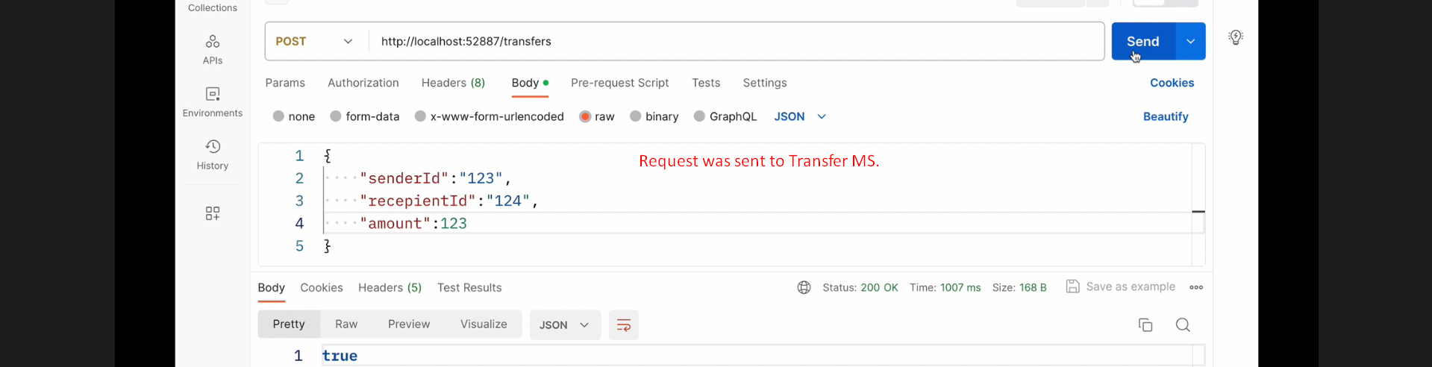
5. 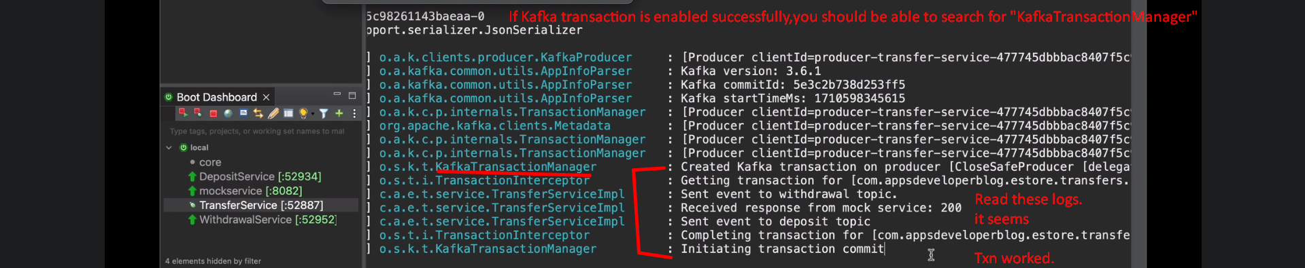
6.   
     
   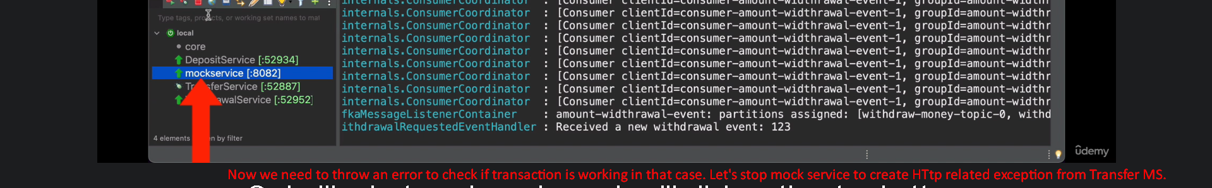
7. 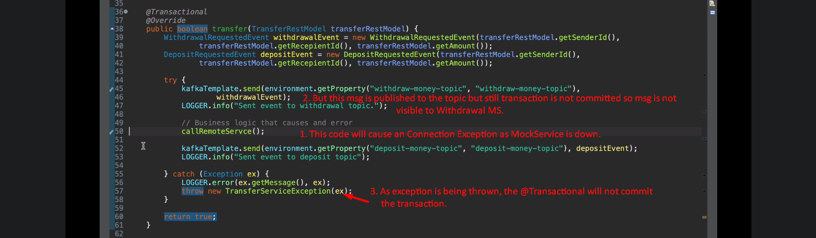
8. 
9. 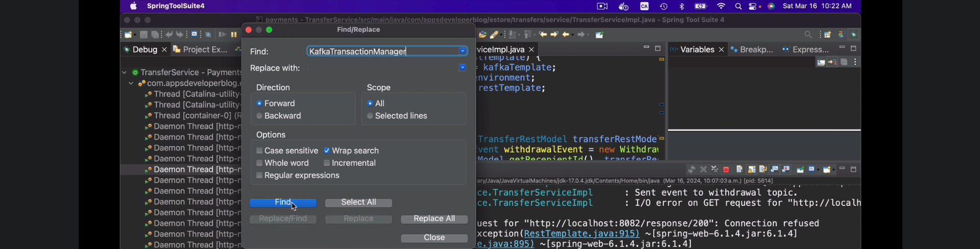
10. 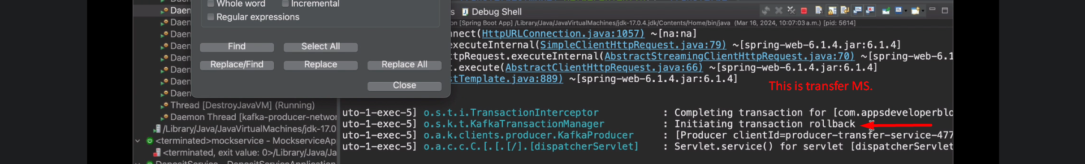
11. 